Ideation Phase
Empathize & Discover

Date | 9 June 2026
Team ID | 24EG105K42
Project Name | ShopEz
Maximum Marks | 4 Marks

Empathy Map Canvas:
An empathy map is a simple, easy-to-digest visual that captures knowledge about a user’s behaviours and attitudes.

It is a useful tool to helps teams better understand their users.
Creating an effective solution requires understanding the true problem and the person who is experiencing it. The exercise of creating the map helps participants consider things from the user’s perspective along with his or her goals and challenges.
Example:


Reference: https://www.mural.co/templates/empathy-map-canvas

Example: Food Ordering & Delivery Application
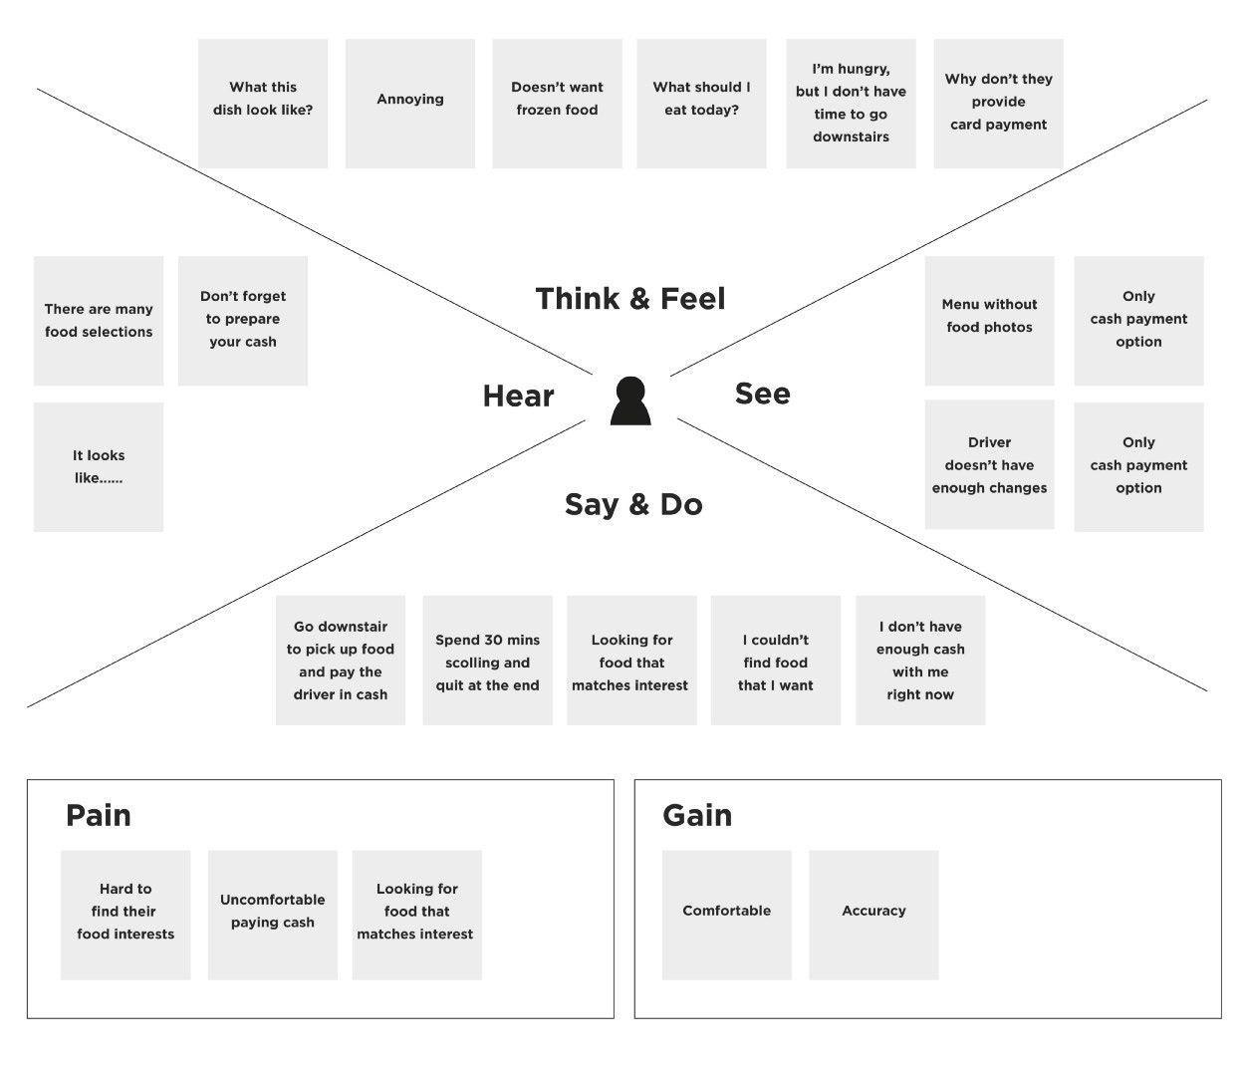

Empathy Map – ShopEZ User

Think & Feel:
- I want to find products quickly without wasting time.
- I want a simple and secure shopping experience.
- I compare prices before making a purchase.
- I expect product information to be clear and accurate.

See:
- Other people shopping on popular e-commerce websites.
- Multiple products and offers available online.
- Different categories such as Fashion, Electronics, Mobiles, and Groceries.
- Reviews and ratings influencing purchase decisions.

Hear:
- Friends recommending online shopping platforms.
- People saying online shopping is convenient and time-saving.
- Advertisements about discounts and special offers.
- Recommendations from family and social media.

Say & Do:
- Search for products using the search bar.
- Browse products by category.
- Add products to the cart before purchasing.
- Compare products and prices before placing an order.

Pain:
- Difficulty finding products on complex websites.
- Too many unnecessary steps during checkout.
- Lack of clear product information.
- Slow website performance and confusing navigation.

Gain:
- Quick and easy product browsing.
- Simple add-to-cart and order placement process.
- Secure user login and account management.
- Easy product management through the admin dashboard.

